**A.  TIMELINE**

|  |  |
| --- | --- |
| Activity | Duration |
| Research: “Survey Results” and “About the Island” | 1 day |
|  |  |
| Sketching/Site map | 2 days |
| Create information architecture/wireframe | 3 days |
|  |  |
| User test wireframe - Guerrilla testing with user tester One | 1 day |
| User test wireframe - Guerrilla testing with user tester Two | 1 day |
| User test wireframe - Guerrilla testing with user tester Three | 1 day |
| Summarize feedback/Clarify plan to include feedback | 2 days |
|  |  |
| Design prototype | 3 days |
| Build prototype/Cite my resources | 1 week |
|  |  |
| Submit prototype for Client-side usability tasks test | 1 day |
| Submit my feedback on three other designs | 3 days |
| Summarize the feedback from others on my prototype | 2 days |
|  |  |
| Revise prototype/Integrate front-end and back-end code | 2 days |
| Summarize how the design has changed | 1 day |
|  |  |
| Launch website |  |

**B.  PERSONA PROFILE**

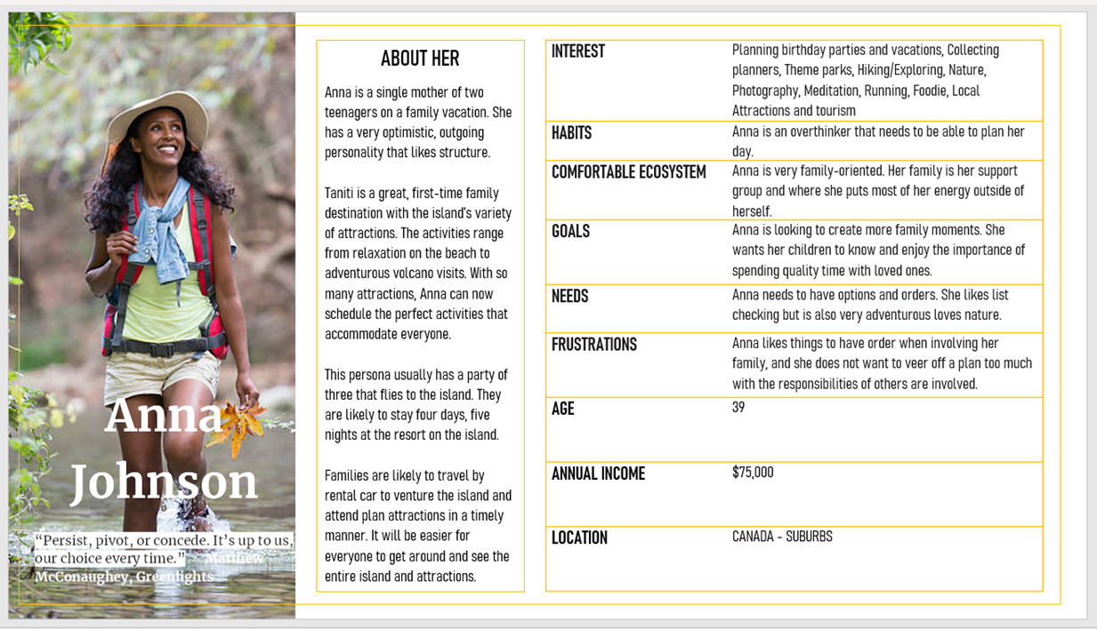

**C.  WIREFRAME**

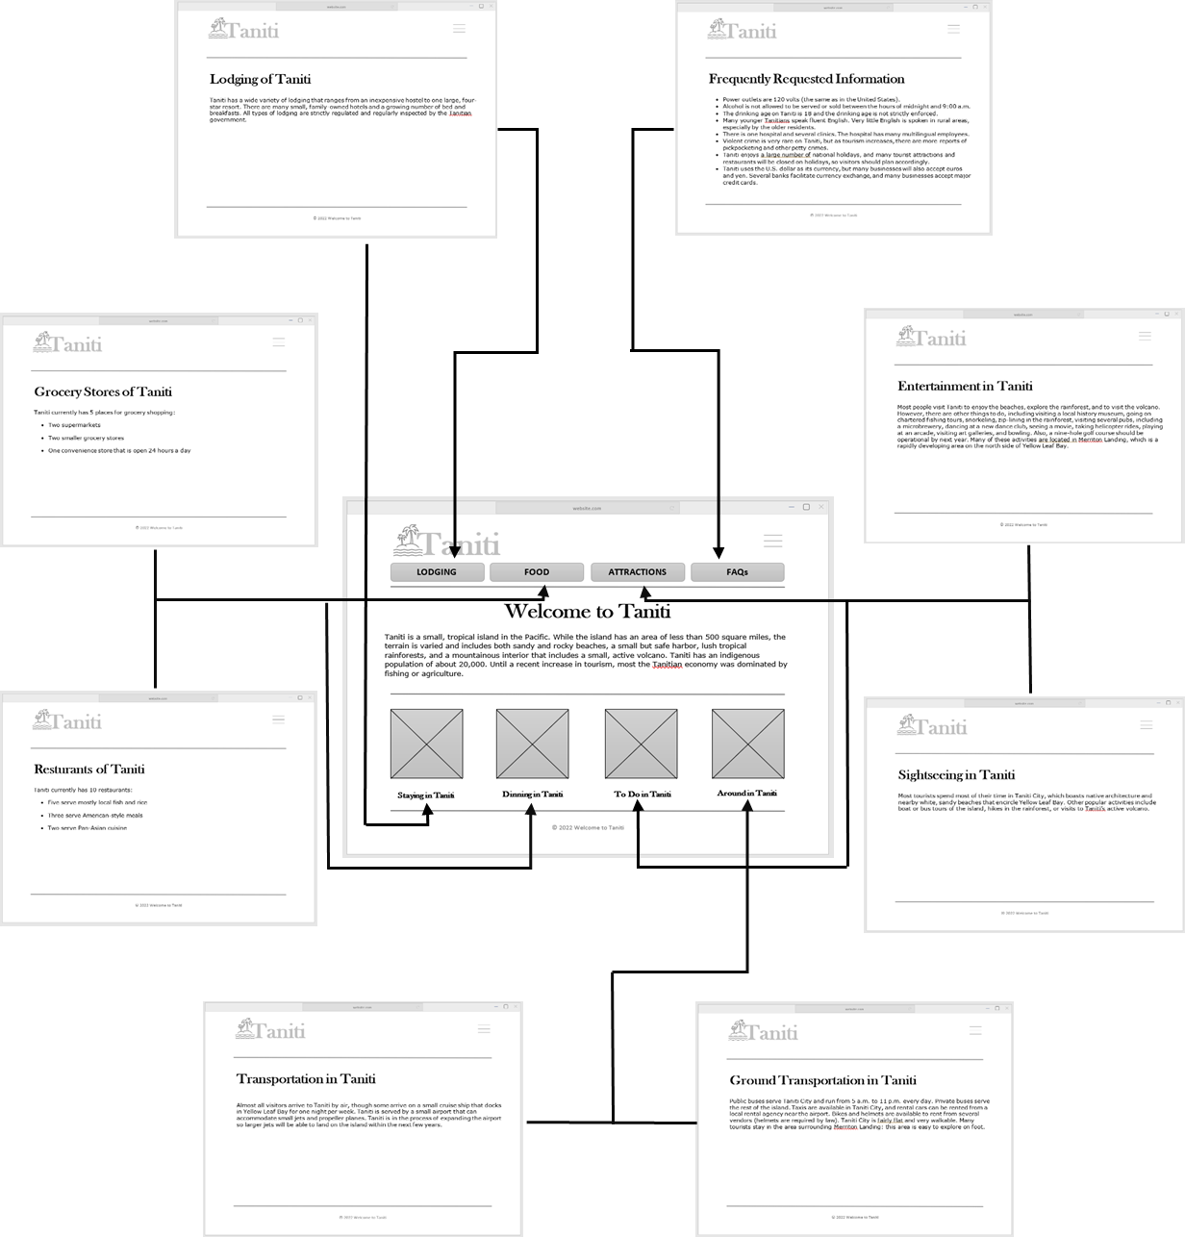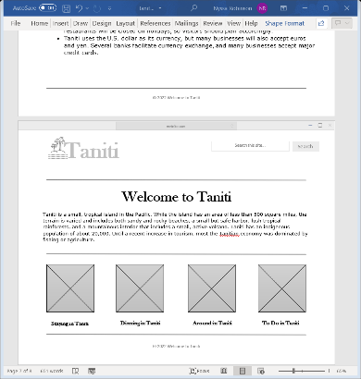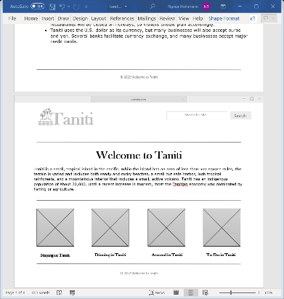

**D.  GUERRILLA USABILITY TESTING**

|  |  |  |  |
| --- | --- | --- | --- |
| Name | Feedback | Actionable | Actions Taken |
| Michelle | The website is boring. There needs to be more pictures. | Actionable | Not enough pictures make the website less engaging for users. I will add six high-resolution pictures, one for each related topic to improve the design. |
| Crystal | There is no way to book a trip. | Actionable | Users need to be able to easily book a trip. There is no page for booking nor a way to get to that page. I will create a booking and contact page. I will also include a booking button at the top of each page. |
| Jimmy | The Home page is the only way to explore the website. | Actionable | Users need to easily navigate to every page. There is no horizontal menu bar on the other web pages. I will add a horizontal menu bar to the top of each page to increase usability. |

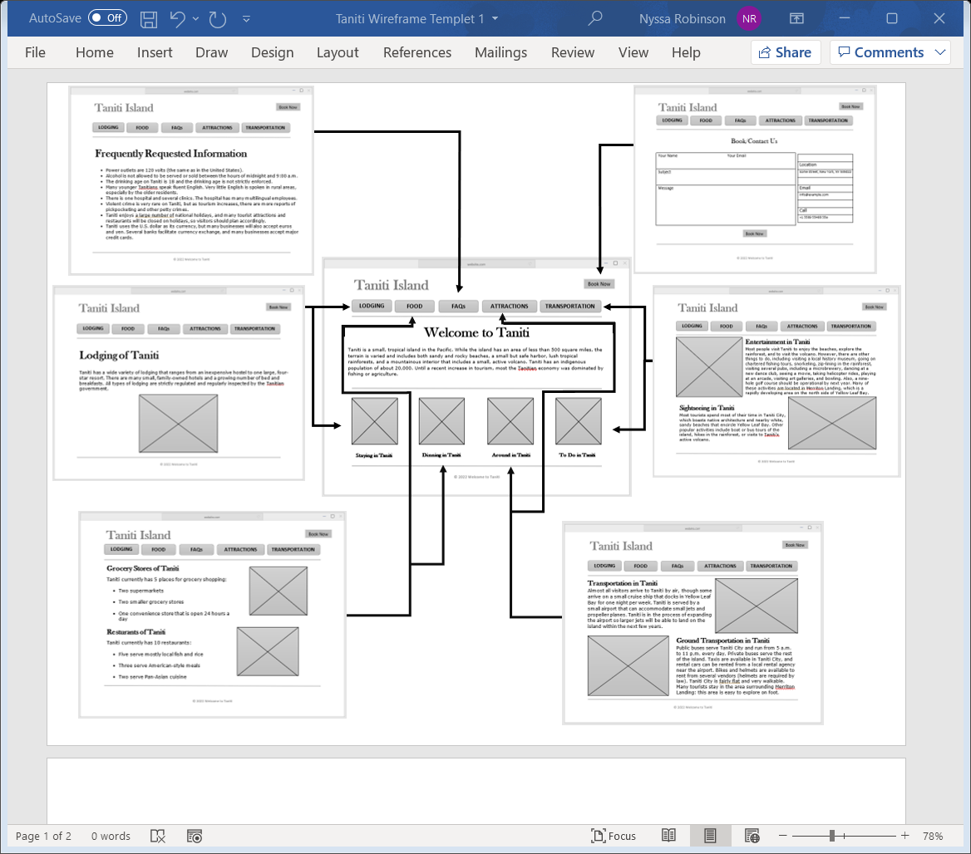***Wireframe (with changes made from feedback):***

*Add background picture to “Welcome to Tahiti” home page.

**E.  INTERACTIVE PROTOTYPE**

[Taniti Prototype.pptx](https://westerngovernorsuniversity-my.sharepoint.com/:p:/g/personal/nrobi71_student_wgu_edu/EQfSornwOUxJovh-XjujzjsBWUaUJzLJ6LpQuZOjjAPGKQ?e=4DAH9g)

**F.  USABILITY TASKS**

1. Name two attractions you can visit on the island.
2. How many hospitals are on the island?
3. Identify two forms of transportation.
4. Locate how many restaurants serve Pan-Asian cuisine.
5. During what time is alcohol is ***NOT*** being served?

**G.  PROFESSIONAL COMMUNICATIONS AND CITAITIONS**

Mlenny. (2019, July 14). *Mount Roto Nui Volcanic Mountain Moorea Island.* iStock. <https://www.istockphoto.com/photo/mount-roto-nui-volcanic-mountain-moorea-island-gm157480366-9951191?utm_source=pixabay&utm_medium=affiliate&utm_campaign=SRP_image_sponsored&utm_content=http%3A%2F%2Fpixabay.com%2Fimages%2Fsearch%2Fvolcano+tropical%2F&utm_term=volcano+tropical>.

Raths, Alex. (2018, July 10). *Assortment of colorful ripe fruits.* iStock. <https://www.istockphoto.com/photo/assortment-of-colorful-ripe-tropical-fruits-top-view-gm995518546-269463390?utm_source=pixabay&utm_medium=affiliate&utm_campaign=SRP_image_sponsored&utm_content=http%3A%2F%2Fpixabay.com%2Fimages%2Fsearch%2Fvariety+of+tropical+fruit%2F&utm_term=variety+of+tropical+fruit>.

Semen, Kuzmin. (2016, March 31). *Last Straw*. iStock. <https://www.istockphoto.com/en/photo/last-straw-gm516329534-88945127>.

Kalinin, Iakov. (2016, April 14). *Tropical sea and rocks.* iStock. <https://www.istockphoto.com/en/photo/tropical-sea-and-rocks-gm518356812-89986479>.

Belvedere, Jonny. (2019, August 10). *Maldives Masculine City Capital City Port Building*. Pixabay. <https://pixabay.com/photos/maldives-masculine-city-4354113/>.

Jag_cz. (2016, April 22). *Sea plane flying above Maldives islands*. iStock. <https://www.istockphoto.com/en/photo/sea-plane-flying-above-maldives-islands-gm519469450-90543677>.

Dashinsky, Ruslan. (2016, November 03). *Woman backpacker wading creek in forest*. iStock. <https://www.istockphoto.com/en/photo/woman-backpacker-wading-creek-in-forest-gm619528130-108059925>.

gawriloff. (2019, February 09). *Regular public bus. Buses are the most widespread public transport type in Sri Lanka.* iStock. <https://www.istockphoto.com/photo/regular-public-bus-buses-are-the-most-widespread-public-transport-type-in-sri-lanka-gm1125682945-296036685?utm_source=pixabay&utm_medium=affiliate&utm_campaign=SRP_image_sponsored&utm_content=http%3A%2F%2Fpixabay.com%2Fimages%2Fsearch%2Fisland+tour+bus%2F&utm_term=island+tour+bus>.

User Experience. (2020, July 30). *30 must-see user persona templates.* Justinmind. <https://www.justinmind.com/blog/user-persona-templates/>.

Ijohn888. (2015, April 14). *Vacations Island Sea Sea View Travel To Travel.* Pixabay. <https://pixabay.com/photos/vacations-island-sea-sea-view-714156/>.

McConaughey, Matthew. (2020, October 20). *Greenlights.* Goodreads. <https://www.goodreads.com/work/quotes/78998213-greenlights>.